**Architecture of Spring framework**

|  |  |  |  |  |  |  |  |  |
| --- | --- | --- | --- | --- | --- | --- | --- | --- |
|  |  |  |  |  |  |  |  |  |
| ORM |  | Web  MVC |  | Web  Integration |  |  |  |  |
|  |  |  |  |  |  |  |  |  |
|  |  |  |  |  |  |  |  |  |
| JDBC  TEMPLATE |  |  |  |  |  |  |  |  |
|  |  |  |  |  |  | Enterprise  Integration |  |  |
|  |  |  | WEB |  |  |  |  |  |
|  |  |  |  |  |  |  |  | Testing |
|  |  |  |  |  |  |  |  |  |
| Tx |  |  |  |  |  |  |  |  |
|  |  |  |  |  |  |  |  |  |
|  |  |  |  |  |  |  |  |  |
|  |  | AOP |  |  |  |  |  |  |
|  |  |  |  |  |  |  |  |  |
|  |  |  |  |  |  |  |  |  |
|  |  | Context |  |  |  |  |  |  |
|  |  |  |  |  |  |  |  |  |
|  |  | IOC |  |  |  |  |  |  |

**In conventional programming**, objects have dependency on each other. These dependency are satisfied by directly referencing one object into another. Direct references of object create tight coupling between them result in maintenance problem.

**Example-**

Let there be three named A,B & C. A has dependency on B which has dependency on C. An application need to do following things in order to use A.

Here, Application Developer is responsible for creating object, satisfying their dependency, and then using them.

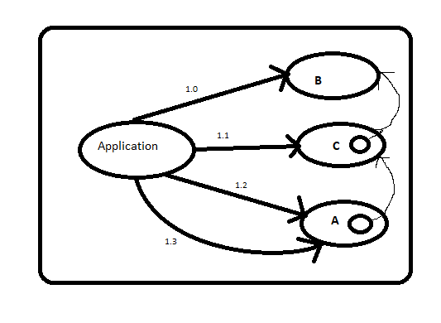

|  |  |
| --- | --- |
| 1.0 | C is instantiated |
|
| 1.1 | B is instantiated & Reference of C is Provided. |
|
| 1.2 | A is instantiated and Reference of B is provided. |
|
| 1.3 | A is Used |
|

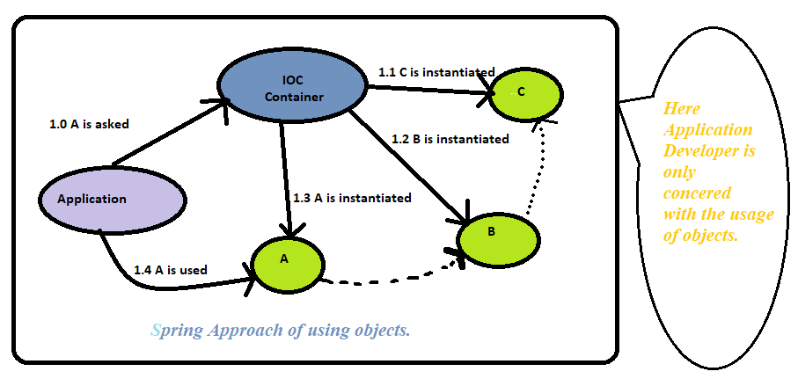

Implementation of IOC can be provided in two ways-

